

PROPOSAL REPORT

Design Studio #4

Project Start Date: 09/11/2018

Project End Date: 01/06/2019

Budget: 200$

Instructor: Gülbin DURAL

Members:

* Fatih ÇALIŞ
* Fatih ÇAM
* Recep GÜNAY
* Huzeyfe HİNTOĞLU
* Sarah ILYAS

Table of Contents

Executive Summary 3

Introduction 4

Company Organization 5

Requirement Analysis 7

Hardware System 7

Mechanical System 7

Processing System 7

Software System 8

Power System 8

Standards for the Project 8

Solution Procedure 9

a. Transmission Subsystem 10

b. Mechanical Subsystem 11

c. Electromechanical and Power Subsystem 11

d. Control Subsystem 11

e. Sensor Subsystem 12

Expected Deliverables 13

Equipments 13

Documents 14

Software 14

Cost - Budget Analysis 14

Time Table 16

Conclusion 17

Appendix - 1: The Determination of the Project 18

# Executive Summary

With the passing of each day, what was science fiction is becoming the reality with the aid of technology. Many science fiction works have tackled the subject of robots participating in human sports and eventually replacing the human factor in them. Nowadays, there are many sports activities in which robots are competing with each other such as robots wrestling and fighting each other. We, as Automata Technologies, are inspired by these developments and are kicking off a new project which will create new possibilities for the future of sports industry.

We will design a robot which will play hockey with a similar robot on a standard hexagonal play field. The robots are to be teleoperated by players from up to 30 meters distance. Some simple parts of the control may be autonomous such as the alignment of the robot and obstacle avoidance. The specifications of the ball, play field, masking tape and robots will be decided in standard committee meetings. The side scoring more than the other wins the game. Although the game sounds simple to play, the design and implementation of the project requires the integration of low latency video transmission and control commands, strong but low power shooting mechanism, smart defense and attack tactics and low cost but effective design choices. However, as Automata Technologies with our intelligent and passionate engineer team, we can overcome all these issues and complete the overall project with success in time by applying efficient and effective labor division, teamwork and integration of the individual knowledge among the company.

The problems to be solved are specified as follows: transmission of the first-person video of the robot, transmission and executing commands, mechanical implementation of the robot and obstacle avoidance. We have proposed several solution methods to each problem and will research on the implementation of these solutions considering budget, feasibility and robustness.

The video transmission is usually a difficult process since the size of the video data is huge and it is a very prominent part of this project. It is prohibited to use Wi-Fi protocol for transmission purpose. Therefore, we have come up with different methods to transmit video. Usage of FPV cameras and transmitter receiver system or Bluetooth 5.0 are two possibilities that we consider and that are feasible in regard to budget and practicality. In order to avoid interference from other transmitter, the channel and frequency band will be chosen. RC transmitters and receivers will be used to issue commands such as shoot and movement commands. Multi channel transmitters are required since there will more than one motion type of the robot. There are ready to use systems in the market, but they are costly for our 200$ limited budget. They can still be used but at the expense of reduced budget for the other parts of the project. If the budget does not allow their usage, we can build our own RC transmitter and receiver system. The mechanical system should be designed so that it will not dissipate too much power and drain the battery while executing the received commands. The shooting mechanism might be a spring structure to consume less power and produce more torque. Also, it should be designed so that the ball will always be in the field of view. For this purpose, the camera should be moveable, and it should be place at a high point looking downward with around 45 degrees to increase the angle of view. In order to avoid hitting the walls and the opponent robot, distance measurement sensors, ultrasonic or infrared, can be used. We can use color sensors or image processing to stay on the field and avoid crossing the goal and middle lines and these avoidance systems can be autonomous and can override the issued commands if necessary.

This document is a proposal for the mentioned product and contains the design and implementation procedures of the project. With scheduled hard work, our product will be ready on time without exceeding the budget as proposed in this document.

# Introduction

As a team, after much deliberation, we winnowed out the choices for our projects, by virtue of pair wise comparison and by weighing the facets and aspects that were most important to us, we picked the project that requires two teleoperated robots to shoot and score in the opponent’s goal. This project entails the design of a sophisticated system that meets the standards and requirements that have been laid out. First and foremost, a communication system between the robot and the operator is the bedrock of this project and therefore is of prime importance. As stated in the requirements for the project, there should be a distance of at least 30 metres between the robot and the operator. Moreover, the robot of each team should be confined to only one half of the entire playing field and should not be in possession of the ball for longer than 20 seconds.

Since this project is inherently mimicking a recreational sport, it holds immense potential to be implemented in actual settings by players in a wide age group. Most importantly, it can be implemented in settings where a player has physical disabilities and cannot perform the actual sport out in the open but can partake in it in a somewhat virtual setting. A case in point is Amyotrophic Lateral Sclerosis patients who have very limited motor control. By virtue of this project, however, they can achieve satisfaction that may be comparable to that achieved by playing the actual sport. Also, like any other sport, this sport, in a virtual setting helps sharpen the reflexes of the players; but unlike real sports which may be disrupted by unfavorable pitch conditions owing to rain or other similar environmental conditions, this one will not be impacted by external circumstances or environmental conditions. In addition, this project is also ideal for children who can learn the tricks of the trade for the game earlier on, before setting out on the field.

This report aims to comprehensively assess the requirements of the project and then lay out the scheme of work that we wish to abide by in order to achieve our goals. Firstly, the requirement analysis will offer an in-depth breakdown of the preliminary specifications of the course. Thereafter, we will propose a solution offer which will, in effect describe our approach to the problem, in the very final section, the appendices depict the pairwise comparison carried out to select a project out of four different candidate projects.

# Company Organization

Automata Technologies consists of 5 highly skilled and motivated engineers who are very knowledgeable and experienced in their respective area of expertise and willing to work interdisciplinary. The flowchart given in Fig1 describes the general task allocation and the specialization areas of the engineers for this project.

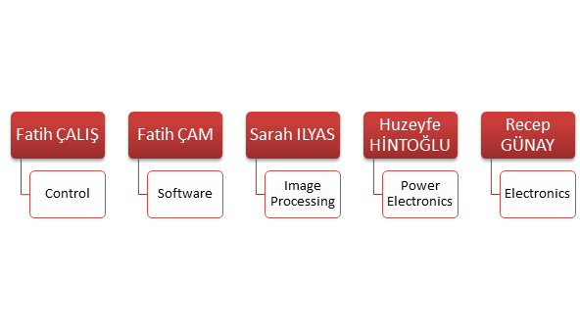

Fig 1: The main work division of the project

Recep Günay serves in the electronics section of the company and he is specializing in electronics area while also taking courses from microwave and computer areas. He is quite knowledgeable in programming with different programming languages such as C and Python. He has hands on experience in digital design with Verilog HDL and image processing using Python and Verilog. He will be responsible for telecommunications subset and he can work together with Sarah Ilyas on image processing if needed.

Fatih Çalış serves in the control section of the company and he is specializing in control area while also taking courses from computer area. He is very experienced in robotics applications and he built several robots on his own in the past. He is also the most knowledgeable among the company members about the mechanical design of a robot. He will be responsible for the control subset and the mechanical design of the robot.

Fatih Çam serves in the software section of the company and he is specializing in computer area. He is very experienced in programming with different languages such as C and Python. He is also quite knowledgeable about digital design with Verilog and VHDL. He also has experience with electromagnetics and telecommunication. He will be responsible for software subset and will work on any kind of coding and can work with Recep Günay on the telecommunications part.

Huzeyfe Hintoğlu serves in the power electronics section of the company and he is specializing in power electronics area while taking courses from computer and control areas. He is very experienced in voltage converter design and usage and motor driver. He is also very knowledgeable about control algorithms and applications. He will be responsible for power electronics subset. He will work on power analysis of the robot and decide what power source, voltage regulators, motor drivers and motors will be used in the robot. He can also work with Fatih Çalış on the control of the robot.

Sarah Ilyas serves in the image processing section of the company and she is specializing in biomedical area. She is very experienced in image processing and sensor usage. She will be responsible for sensor subset of the project and image processing subset if needed. She will decide what kind of sensors to use and she will work on reading and optimizing the sensor outputs.

Every company member will work on feasibility research, integration of subsystems and troubleshooting together.

# Requirement Analysis

## Hardware System

* There will be two DC motors to rotate the wheels to move the robot fast enough to beat the opponent. These motors will be fed by the commands coming from the microprocessor. The feedback of position and orientation will be sent to microprocessor by encoders which are compatible with the speed of the robot.
* There will be a mechanism for shooting the ball. A relay implemented shooting mechanism or a continuously rotating mechanism with another DC motor can be implemented.
* The hardware system will be energized by a battery to run the robot the robot at least 30 minutes.
* The hardware system will be provided by protection equipment to work at least 2 years.

## Mechanical System

* Our robot should turn 360° in the flat so that we can move freely in the field in order to be able to hit the ball.
* The robot should hit or drive the ball with suitable mechanism.
* The robot should fit inside a flat which has 65 cm diameter.
* There will be a camera implemented on board which makes operator to see the field and the ball with wide angle.

## Processing System

* The microcontroller should be powerful enough to manage process all the information coming from sensors.
* Since we need high speed in movement, the microcontroller should be able to process the data coming from sensors and apply the commands to robot as fast as possible.
* All the motors of the robot will be driven simultaneously.

## Software System

* All the programming will be embedded.
* There should be a interface to see the operation of robot with the monitor.
* Image processing may be used for object detection i.e. ball and goal-line detection in defense mode.

## Power System

* It should be able to run with an external power source, generally with LiPo batteries.
* Power consumption should be minimized as much as possible.

# Standards for the Project

There are some standards which are defined at the beginning of the project. Robots should be designed according to these standards. Also, these standards will be discussed at the standard committees and finalized in the following weeks.

#### • Communication:

* Robots should be designed such that they can be controllable at least 30 m far from the play-field.
* Wired connection or use of Wi-Fi is not allowed.

#### • Robot Design:

We will design a tele-operated robot to take part in a hockey game, against a similar robot and robots should have these properties:

* The robots are free to move in their own half-field only.
* Intervention of competitor’s field is not allowed.
* The robot, at all times, must fit inside an “upright” cylinder of 65 cm. in diameter.
* Robots are only allowed to hit, push or otherwise drive the ball
* Robots are not allowed to grasp, scoop or otherwise carry the ball.
* Robots must be tele-operated though it can operate semi-autonomous in some cases.

#### • Field Design:

Teams are expected to provide to form their own half-field, with width, length and thickness (height) commonly agreed upon at the standard committees, without any markings, except the goal lines and centerline.

* The game field is built in the shape of hexagon with the walls in length between 70-75 cm.
* The game field include two half area which are separated from each other by a centerline.
* Each team has their own goal lines with the length of at least twice of the robot in their half field.
* The height, colour and the material of the walls will be decided in standard committees.

#### • Ball Selection:

* Ball’s diameter will be in between 30-45 mm.
* The height, colour and the material of the ball will be decided in standard committees.

#### • Game Rules:

* The ball should be sent to opponents’ half field no more than 20 seconds.
* The robot which scored 2 goals firstly will win the competition.
* Robots cannot grasp the ball, only hit, push or otherwise drive the ball as mentioned before.
* The game should be played in Fair-Play.
* Players cannot see the play-field with naked eye. There should be a monitoring system or algorithm implemented for this purpose.

# Solution Procedure

The robot in this project is a tele-operated robot that tries to score by pushing or hitting a ball into the opponent’s goal, directly or indirectly. The operator remotely controls the robot (from a distance up to at least 30 meters) without actually monitoring the play-field with naked eye; the only means of monitoring the field is by means of a camera mounted on board the robot. In order to have reasonable solutions for the problems, the system must be analyzed with dividing it into subsystems so that the overall system can meet all the requirements. The system is composed of five subsystems that are Transmission Subsystem, Mechanical Subsystem, Electromechanical Subsystem, Control Subsystem, and Sensor Subsystem. In this project, there is one more optional operation. The robot can have defense mode. In this mode, the robot actions autonomously. If we can find cheaper solutions for the tele-operated mode, then we can consider autonomous defense mode. In this case, one more subsystem which is Image Processing will be added.

## a. Transmission Subsystem

As mentioned before, the operator will control the robot from a distance upto at least 30 meters. Therefore, only way that the operator can monitor the field is by using a camera mounted on the robot. This requires life video stream with sufficient resolution and frame per second for proper operation. The solution for live video stream is FPV camera set. A FPV camera set is composed of a camera, an analog video transmitter with antenna, and a receiver. Since, the FPV cameras work on analogue video, their resolution is measured in TV lines or TVL rather than pixels. There are some options for TVL such as 420, 480, 600, 800 and 1000. Latency is another factor, which highly depends on both the distance and the quality of the transmitted video. It is usually around 50ms, which is ideal for our project. The transmitter basically processes the image that is captured by the camera and encode this data into an analog signal with a high frequency. The most commonly used frequencies by FPV cameras are 900MHz, 1.2GHz, 2.4GHz and 5.8GHz. Considering the obstacles that will be put on the area, 5.8 GHz is convenient for our project to transmit live video. The receiver decodes the signal that is radiated by the transmitter and convert this data into a digital form. After this conversion, a screen is used to convert the data into a video. The screen is a smartphone or a monitor.

In summary, FPV camera will capture image with enough resolution and frame per second. Then the transmitter will make process on the image and send it to the receiver in analog signal mode with high frequency, and the receiver will encode the signal and make conversion from analog to digital. Finally, the converted image will be displayed on a screen.

## b. Mechanical Subsystem

Mechanical subsystem consists of robot chassis and hitting mechanism. The chassis can be 2WD or 4WD. If we use 2WD chassis, then we will put one ball caster so that the robot can easily manoeuvre and reach the ball as soon as possible. If we use 4WD chassis, we are planning to use 360-degree rotating wheels. These wheels make the robot capable of moving directly in different directions. As the hitting mechanism, we are going to use a spring system. When the robot reaches the ball, it will take proper position and compress the spring. When it releases the spring, the mechanism will hit the ball with enough force and send it straightly.

## c. Electromechanical and Power Subsystem

Electromechanical subsystem is composed of motors and motor driver. Basically, it is responsible for moving the robot. We are going to use DC Brushed motors and L298 motor driver (H- Bridge). These components are commonly used for this purpose and easy to use. For power supply, we will use LiPo battery. LiPo battery is the most convenient one because it has higher weight-energy rate, volume-energy rate, high voltage, and long lifespan. It also keeps for long because of the low self-discharging rate. Moreover, we are planning to put servo motor that is connected to camera the on the robot so that we can move the camera to have a better sight. This also plays very important role for the project because we have to have as better sight as possible to make proper movements with the robot in order to reach the ball and take action on time.

## d. Control Subsystem

Control subsystem consists of two parts. One is remote control devices and the other one is microcontroller. For the remote-control devices, we have two solution approaches. The first one is using 6-Ch RC Transmitter & Receiver. We are planning to use 4 channels for controlling the robot movements, 1 channel for adjusting the camera angel, and the last channel for shooting. This device quite practical and convenient for the project. It is in low power consumption for durable using. It also high receiving sensitivity. Despite all these advantages, it is quite costly when we consider budget limit. Therefore, we have another solution for remote control. The solution is building our own 7 channel RC transmitter and receiver using 2 NRF24L01 RF Transceiver IC and 2 Arduino NANO. The nRF24L01 is a highly integrated, ultra low power (ULP) 2Mbps RF transceiver IC for the 2.4GHz ISM (Industrial, Scientific and Medical) band. This frequency band is the same with the one in the first solution. It enables the implementation of advanced and robust wireless connectivity with low cost 3rd-party microcontrollers. The microcontroller will be Arduino NANO. This solution will decrease the cost for remote control part. Therefore, we will be able to allocate some budget for the optional autonomous mode of the robot. For the microcontroller that is embedded on the robot, we have again different solution approaches for different cases. If we use 6-Ch RC Transmitter & Receiver that is available on the market, we will be using Arduino NANO or Tiva TM4C123GXL. Arduino NANO is the simplest solution between them. It will get the signal (sent by RC transmitter) from the receiver and control the robot according to instructions. It can handle the requirements for controlling the robot. Tiva C Series controller is another option and can have better features. The most remarkable feature is the clock speed. It provides more speed and programing flexibility than Arduino NANO. The last option is Raspberry Pi. This option will be considered only if we can build our own 7-Ch Transmitter and Receiver. In this case, we will have autonomous mode for the robot and this requires image processing. Raspberry Pi is the suitable one for this purpose.

To sum up, control subsystem’s function is that Transmitter sends the signals to the receiver that is on the robot, then the receiver generates pulses and sends them to the microcontroller and finally microcontroller interprets these signals and generate commands for the robot. At the end, the robot moves according to the instruction that is sent by the operator.

## e. Sensor Subsystem

Sensors are used to measure a property, such as pressure, distance, position, temperature, or acceleration, and respond with feedback. According to the feedback, the robot takes action to fulfill its duties. If we do not include autonomous mode for the project, then the only sensor we will be using is a color sensor. The color sensor product provides RGB (Red, Green, Blue) light sensors for precise color measurement, determination, and discrimination. We are going to use the color sensor to identify center-line and goal lines marked by “masking tape” because the robot is forbidden to pass on center-line and get behind the goal line. If we can handle budget issue and have autonomous mode, then we will include distance measurement sensor which is HCSR-04 and Inertial Measurement Unit which is MPU6050. HCSR-04 is the most well-known and available distance measurement sensor. This ultrasonic sensor has a 3mm sensitivity and 2-400cm range. It can be used in distance measuring, radar and robot applications. We are planning to use this sensor to measure distance between the robot and the walls so that the robot does not hit the wall. MPU-6050 is a six-axis IMU sensor card which includes a triaxial gyro, a triaxial angular accelerometer and often used in various robotic projects. It is very accurate, as it contains 16-bits analog to digital conversion hardware for each channel. Therefor it captures the x, y, and z channel at the same time. The sensor uses the I2C-bus to interface. The sensor will make measurements and then send the data to the controller. Using the feedback data that comes from IMU, the controller will stimulate the robot to take action and have proper position to defend ist goal and attack to score a goal.

# Expected Deliverables

## Equipments

#### Vehicle (Robot)

* The user will be provided with a robot to compete with another robot on the play field.

#### Play Field

* The user will be provided with a robust hexagonal play field on which two robots can play hockey.

#### Ball

* The user will be provided with a ball whose specifications will be decided later in standard committee meetings.

#### Goals

* The user will be provided with two goals for each player with the play field.

#### Control Interface

* The user will be provided with a control interface system consisting of a RF transmitter to send commands and a screen to watch the video coming from the robot for decision making.

## Documents

#### Warranty

* Automata Technologies provides a two-year warranty in the event of a failure in the hardware or the software part of the robot except in a user fault case.

#### Manual

* The user will be provided with a manual on how to operate the robot using the RF transmitter and to set up the control interface.

## Software

#### CD

* The user will be provided with a CD containing the manual in a tutorial manner in both video and document formats.

# Cost - Budget Analysis

The budget of the project is limited with 200$. Therefore, depending on the desired features of the robot, we have different alternatives for the objectives to adjust the cost-budget relation in a most optimal way. For example, if the robot is to be fully teleoperated, then we will have a 6 Channel RC transmitter and receiver, to improve the quality of the remote control. On the other hand, if our robot will have an autonomous defense mode, then we need an on-board computer for the image processing, which limits the budget. Thus, the 6 channel RC transmitter cannot be used.

Although all the components to be used in this project are not determined at this stage, the approximations for the cost corresponding to the component used for the described subsystems are as follows:

* Video Transmission Subsystem:
  + FPV camera & Video Transmitter ≈ 40$
  + Receiver ≈ 30$
* Control Subsystem:
  + 2 options for the remote control:
    1. 6-Ch RC Transmitter & Receiver ≈ 50$
    2. 2 NRF24L01 + 2 Arduino NANO ≈ 15$
  + 3 options for the Microcontroller:
    1. Arduino UNO ≈ 3$
    2. Tiva TM4C123GXL ≈ 13$
    3. RaspberryPi ≈ 30$
* Sensor Subsystem:
  + 2 options for color sensor:
    1. CNY70 ≈ 1$
    2. TCS3200 ≈ 5$
  + Distance Measurement: HCSR-04 ≈ 1.5$
  + Inertial Measurement Unit: MPU6050 ≈ 2$
* Mechanical Subsystem:
  + Two options for the chassis:
    1. 2WD Robot chassis ≈ 8$
    2. 4WD Robot chassis ≈ 10$
* Electromechanical & Power Subsystem:
  + Battery: LiPo ≈ 20$
  + DC Motors are included in the chassis
  + Servo Motor: SG90 ≈ 1.5$
  + Motor Driver: L298 ≈ 2$

# Time Table

The time plan for the project is determined by estimating the duration for design, tests and implementation of the subsystems namely, transmission, mechanical, electromechanical & power, control and sensor subsystem. It is more appropriate to spare more time on the transmission and the control subsystem since both of them are considered as the most complex and crucial parts of the project.

The integration of the subsystems will probably lead to some mechanical, interference or wiring problems and therefore, we have spared the last month and a half on the troubleshooting. The ganchartt created for the project is given in Fig2.

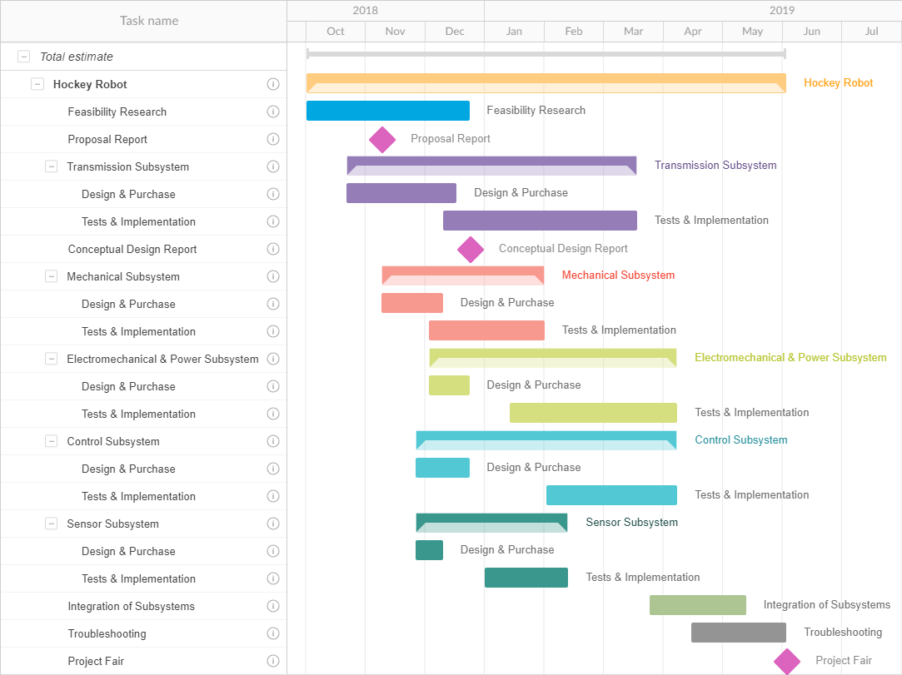

Fig 2: The time table of the processes in the project

# Conclusion

In today’s day and age, there is a surge in technologies that operate by virtue of telerobotics. As enterprising engineers, we at Automata Technologies strive to take quantum leaps in the right direction by integrating innovation with cutting edge technology and thorough research. This venture, wherein we shall devise a strategy and design a teleoperated robot is just another case in point. In this project, specifically, our aim is to design and create a teleoperated robot for playing hockey. During the implementation of our design, some elements are very crucial and and form the groundwork of our initiative; these include, transmission of first-person video of the robot, circumventing obstacles and maintaining alignment, in addition to the ability to teleoperate the robot from a distance of at least 30 metres. In a similar vein, tools that enable low latency need be employed in order to have a dexterous robot. On the other hand of the spectrum, from a mechanical perspective, this project also calls for an ingenious and effective method for shooting the ball and nimble attack and defense moves. By conducting thorough research, which is still ongoing, we have been able to come up with appropriate methods to confront each problem; for instance, an inherent need of this project is the ability to stream live video with sufficient resolution and frames per second for a receptive and responsive robot. In order to tackle this issue, we decided to implement our project by employing FPV cameras. In order to perform trivial acts such as repositioning or alignment, some elements of autonomous control may be incorporated within the robot. However, as projected, our robot will mainly be teleoperated. For the purpose of the Control system, we plan to create our own 7 channel RC transmitter and receiver using 2 NRF24L01 RF Transceiver IC and 2 Arduino NANO. For sensory modules, we shall utilize color sensors, and if our budget permits, a distance measurement sensor and Inertial Measurement Unit may also be used. Therefore, for our prospective clients, we offer a versatile product. This product may be employed by disparate people, from sport coaches to ALS patients. As pioneers of this company, this is one of the very first technological enterprises we have undertaken and one of our aspirations is to offer the most innovative solution to our consumers. As a nascent and budding company, we are very conscious of the impact we make on our environment; one of the preliminary standards of our company is to ensure that our products create no adverse environmental effects.

Conclusively, we at Automata Technologies believe that our product will live up to the clients’ expectations and its accomplishment will be a notch on our belts.

# Appendix - 1: The Determination of the Project

|  |  |  |  |  |  |  |  |
| --- | --- | --- | --- | --- | --- | --- | --- |
|  | Creativity | Experience | Fun | Marketability | Easiness | Inexpensiveness | Total |
| Marketability | 0 | 0 | 0 | - | 1 | 1 | 2 |
| Creativity | - | 1/2 | 1 | 1 | 1 | 1 | 4.5 |
| Inexpensiveness | 0 | 0 | 0 | 0 | 0 | - | 0 |
| Fun | 0 | 0 | - | 1 | 1 | 1 | 3 |
| Experience | 1/2 | - | 1 | 1 | 1 | 1 | 4.5 |
| Easiness | 0 | 0 | 0 | 0 | - | 1 | 1 |

Table1: Pairwise comparison of the criterias

After the pairwise comparison, the weights are calculated as follows:

* Creativity: %26.2, Fun: %19, Inexpensiveness: %4.8
* Marketability: %14.3, Easiness: %9.5, Experience: %26.2

With the weights obtained, the next thing is to vote and to calculate each point of the project. The result of the vote is shown in Table 2. Note that, the points are the average point given by the team members.

|  |  |  |  |  |  |  |  |
| --- | --- | --- | --- | --- | --- | --- | --- |
|  | Creativity | Experience | Fun | Marketability | Easiness | Inexpensiveness | Total |
| Catching Balloons | 4.4 | 6 | 5.2 | 3.2 | 5.6 | 6 | 5.41 |
| Hockey Game | 9.2 | 7.2 | 9.4 | 8.8 | 7.2 | 3.6 | **6.96** |
| Chasing Each Other | 4.8 | 4.8 | 4.4 | 4 | 7.6 | 5.6 | 6.05 |
| Mapping a Region | 8.8 | 7.6 | 5.2 | 7.6 | 1.6 | 2.8 | 4.04 |

Table2: The result of the weighted voting about the project